**Thinking Like a Physicist**

**Hawking Temperature Thought Experiment**

Stephen Hawking is famous for showing that black holes aren’t black. Hawking showed that a black hole with mass $M$ glows like a hot coal with temperature

$$T_{BH}=\frac{hc^{3}}{16π^{2}kGM}$$

This “Hawking temperature” was one of the first major milestones towards achieving a theory of quantum gravity. Working in groups, you will conduct a thought experiment that leads to this important prediction by combining ideas from three main areas of theoretical physics: thermodynamics, Einstein’s relativity theory (special and general), and quantum theory.

**Introduction**

There are four key steps in this thought experiment. Each group will read through and understand the general flow of the argument given below, and work through the details of **one** step.

1. 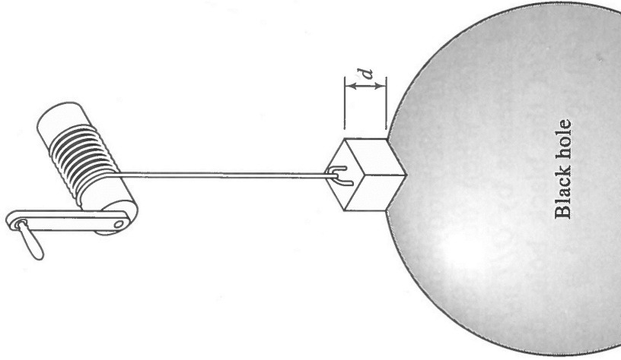**General Relativity.** Imagine lowering a box of mass $m_{box}$ from a very great height down to the event horizon of a black hole by unwinding a winch (see diagram). Because the box wants to fall toward the black hole, we actually have to hold back on the winch, which means we can extract useful energy as we lower the box down. **Fact: According to Einstein’s general theory of relativity (his theory of gravity), the amount of useful energy we can extract at the winch is equal to the *entire* rest mass energy of the box: $E=m_{box}c^{2}$** .
2. **Special Relativity.** All objects emit thermal radiation, which is a form of electromagnetic waves (e.g., this is what “night vision” goggles see). Imagine that the inside surface of the box is made of perfectly reflecting mirrors, and that we trap some thermal radiation inside, so that the total amount of thermal energy inside the box is $E_{th}$. **Fact: According to Einstein’s special theory of relativity, the inertial mass of this thermal radiation is $m_{th}=E_{th}/c^{2}$, which increases the amount of useful energy we can extract at the winch by an amount $m_{th}c^{2}=E_{th}$** . (Yes, adding light to a box increases its inertial mass. It weighs more, and is harder to accelerate.)
3. **Thermodynamics.** When the box filled with thermal radiation reaches the event horizon, a mechanism opens the bottom of the box and the thermal radiation empties into the black hole. We now winch the empty box back up to its starting position. Because the box is lighter on the way up, we expend less energy winching it up than we gained winching it down. The net gain in useful energy is $E_{th}$. We can refill the box with thermal energy and repeat this cycle any number of times we like. We have thus constructed a *cyclical* machine (called a *heat engine*) that will convert thermal energy *entirely* into useful mechanical work. **Fact: According to thermodynamics, this implies that a black hole has a temperature $T_{BH}=0$ (absolute zero), i.e., it emits no thermal radiation and so is black.**
4. **Quantum Theory.** Our thought experiment so far has ignored quantum theory. In order for the thermal photons to “fit” inside the box, the height of the box (labelled $d$ in the diagram) must be at least equal to half the wavelength of the photons (and this wavelength depends on the temperature of the thermal radiation). This means the centre of mass of the thermal radiation can only be lowered to within a distance $d/2$ of the event horizon, not all the way down. In other words, we cannot quite extract the full amount of energy, $E_{th}$, at the winch. **Fact: According to thermodynamics, this quantum effect reduces the efficiency of our heat engine, and implies that the black hole has the non-zero temperature, $T_{BH}$, given above**.

**Class Discussion**

Any object warmer than absolute zero must emit thermal radiation, and so a black hole *itself* should emit thermal radiation (called *Hawking radiation*).[1] It should glow like a hot coal with temperature $T_{BH}$. Indeed, it should be subject to *all* the laws of thermodynamics. **Fact: According to the second law of thermodynamics, a black hole at the temperature $T_{BH}$ predicted above should have a thermodynamic *entropy* equal to**

$$S_{BH}=\frac{k}{4}\frac{A}{l_{P}^{2}}$$

where $A$ is the surface area of the black hole and

$$l_{P}=\sqrt{\frac{hG}{2πc^{3}}}≈1.6×{10}^{-35} m$$

is the Planck length. “Entropy” can be thought of as a measure of “missing information”, in this case, information in the matter that collapsed to form the black hole, which is now behind the event horizon, and so inaccessible. The fact that the entropy is proportional to the surface *area*, and not the volume, is very surprising (think about it!). Nevertheless, it is widely believed that any proposed theory of quantum gravity must satisfy this black hole entropy law. If it doesn’t, it’s probably wrong. Proposed theories of quantum gravity such as superstring theory and loop quantum gravity satisfy this law.

**Hawking Temperature Thought Experiment Part 1―General Relativity**

In this part of the thought experiment we will think about how much useful energy we can extract from the winch, in both Newton’s and Einstein’s models of gravity.

1. Let’s start with a simple example and work our way up. Suppose an object of mass $m$ is lowered from a small height $h$ down to the surface of the Earth by unwinding a winch (imagine that the rope is massless and the winch is frictionless). If $g$ is the acceleration of gravity at the surface of the Earth, how much useful energy can be extracted at the winch?
2. In Question #1 we assumed that the height, $h$, is small compared to the radius of the Earth, $R$, so that the acceleration due to gravity was approximately constant as we lowered the box. But if $h$ becomes comparable to $R$, or larger, we have to take into account the fact that the acceleration due to gravity depends on the distance, $r$, from the centre of the Earth. Recall Newton’s law for gravitational acceleration (or force) and argue that the useful energy that can be extracted at the winch is a function of the height, $h$, and is given by the integral
$$E_{Newton}(h)=\int_{R}^{R+h}{m \frac{GM}{r^{2}} dr}$$

3. Evaluate this integral. If the height, $h$, is very much *smaller* than the radius of the Earth, use the binomial approximation to show that the value of the integral reduces to $mgh$, where $g=GM/R^{2}$. Does this agree with your answer to question #1? If the height, $h$, is very much *larger* than the radius of the Earth (let $h→∞$), show that the value of the integral reduces to
$$E_{Newton}(h→∞)=m \frac{GM}{R}$$

4. If we compressed the mass of the Earth into a smaller radius, the strength of gravity at Earth’s surface would increase, as would the velocity required to escape from the surface. If we compressed the radius down to $R=2GM/c^{2}$ (about the size of a peanut), the escape velocity would become the speed of light. This is the Newtonian version of a black hole. If we lowered the object from infinity down to the surface (“event horizon”) of such a Newtonian black hole, show that the useful energy we could extract at the winch is *half* the rest mass energy of the object:

$$E_{Newtonian BH}(h→∞)=\frac{1}{2}mc^{2}$$

1. Imagine a circle of circumference $2πr$ centred in the equatorial plane of the Earth (see diagram on next page). In Einstein’s model of gravity, the mass of the Earth *warps* space both inside and outside the Earth in such a way that the physical distance, $d$, that you would have to “walk” to get from a point on the circle to the centre of the Earth would be *greater* than $r$ (see diagram). In other words, there is *more space* inside the circle than expected, based on its circumference. This means that for an *Einsteinian* black hole, we would need a *longer* rope to lower the object down to the event horizon. We would need to turn the winch more times, and hence we would extract more useful energy at the winch. The amount of energy extracted is given by the same integral in Question #2, except with $dr$ replaced by $dr/\sqrt{1-2GM/c^{2}r}$ to account for the warping of space:

$$E_{Einstein}(h)=\int_{R}^{R+h}{m \frac{GM}{r^{2}} \frac{1}{\sqrt{1-2GM/c^{2}r}}dr}$$

If we take $R=2GM/c^{2}$ (i.e., compress the Earth to a black hole), and take the limit $h→∞$ (i.e., lower the object down from a very great height, effectively infinity), the value of this integral turns out to be *twice* that for a Newtonian black hole:

$$E_{Einsteinian BH}(h→∞)=mc^{2}$$

Where does this energy *come from* (in both Newton’s and Einstein’s models of gravity)?

(Note: Throughout this discussion we have been assuming that the object can be made as thin as we like―we can flatten it like a pancake, so we can bring all of its mass as close as we want to the event horizon, without any part of it actually going into the horizon. This is possible in a classical world, but not, as we shall see in Part 4, in a quantum world.)

1. Summarize the argument leading to the statement: **According to Einstein’s theory of gravity, the amount of useful energy we can extract at the winch is equal to the *entire* rest mass energy of the object: $E=mc^{2}$.**

**radius $=d>r$**

**circumference $=2πr$**

Diagram for Question #5

**Hawking Temperature Thought Experiment Part 2―Special Relativity**

In this part of the thought experiment we will think a bit about the nature of thermal radiation, and whether thermal radiation in a box has mass.

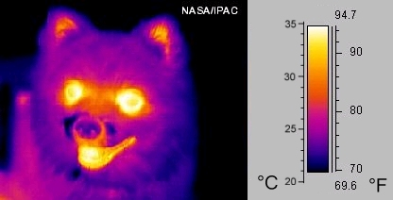All objects emit thermal radiation, which is a form of electromagnetic waves. This radiation occurs over a range of wavelengths, and depends on the temperature of the object. In physics, temperature is always measured in Kelvin (K). The absolute zero of temperature is 0 K, or about $-273$ degrees Celsius. Room temperature is about 300 K. **Thermal radiation depends on temperature in two ways**:

1. The *hotter* an object is, the more *brightly* it glows. In other words, a *hotter* object emits *more* thermal radiation, i.e., the area under the curve in the graph below *increases*.

**Question:** Imagine two stars of equal size, with surface temperatures of $4500$ K and $5500$ K, respectively. From the graph, estimate about how many times brighter the hotter star is compared to the colder star.

1. The *hotter* an object is, the more the colour of its glow shifts toward the *blue* end of the spectrum. In other words, a *hotter* object glows most brightly at a *shorter* wavelength, i.e., the peak in the curve in the graph below shifts to the left.

**Question:** The Sun’s surface is at a temperature of about $5800$ K. From the graph, estimate the wavelength at which the Sun emits thermal radiation most intensely. From the spectrum below right, at what colour does the Sun glow most brightly?

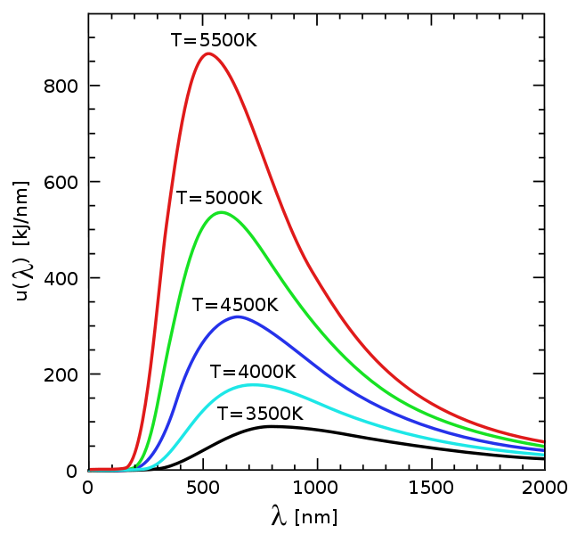

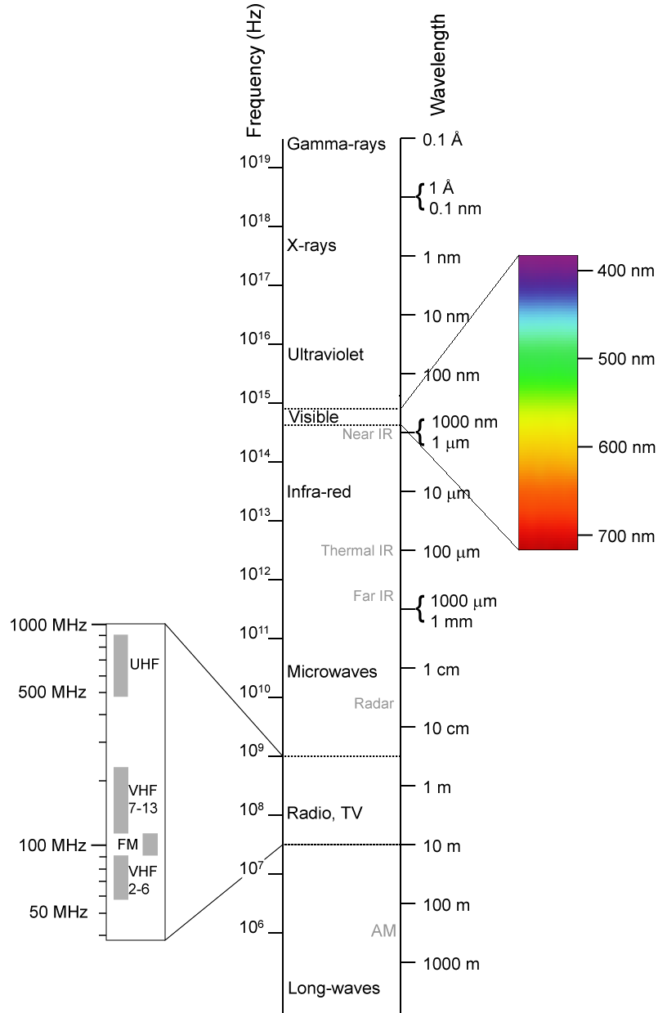

We will now trap some of the thermal energy emitted from an object at temperature $T$ inside a mirrored box. Let’s think about how this might affect the mass of the box.

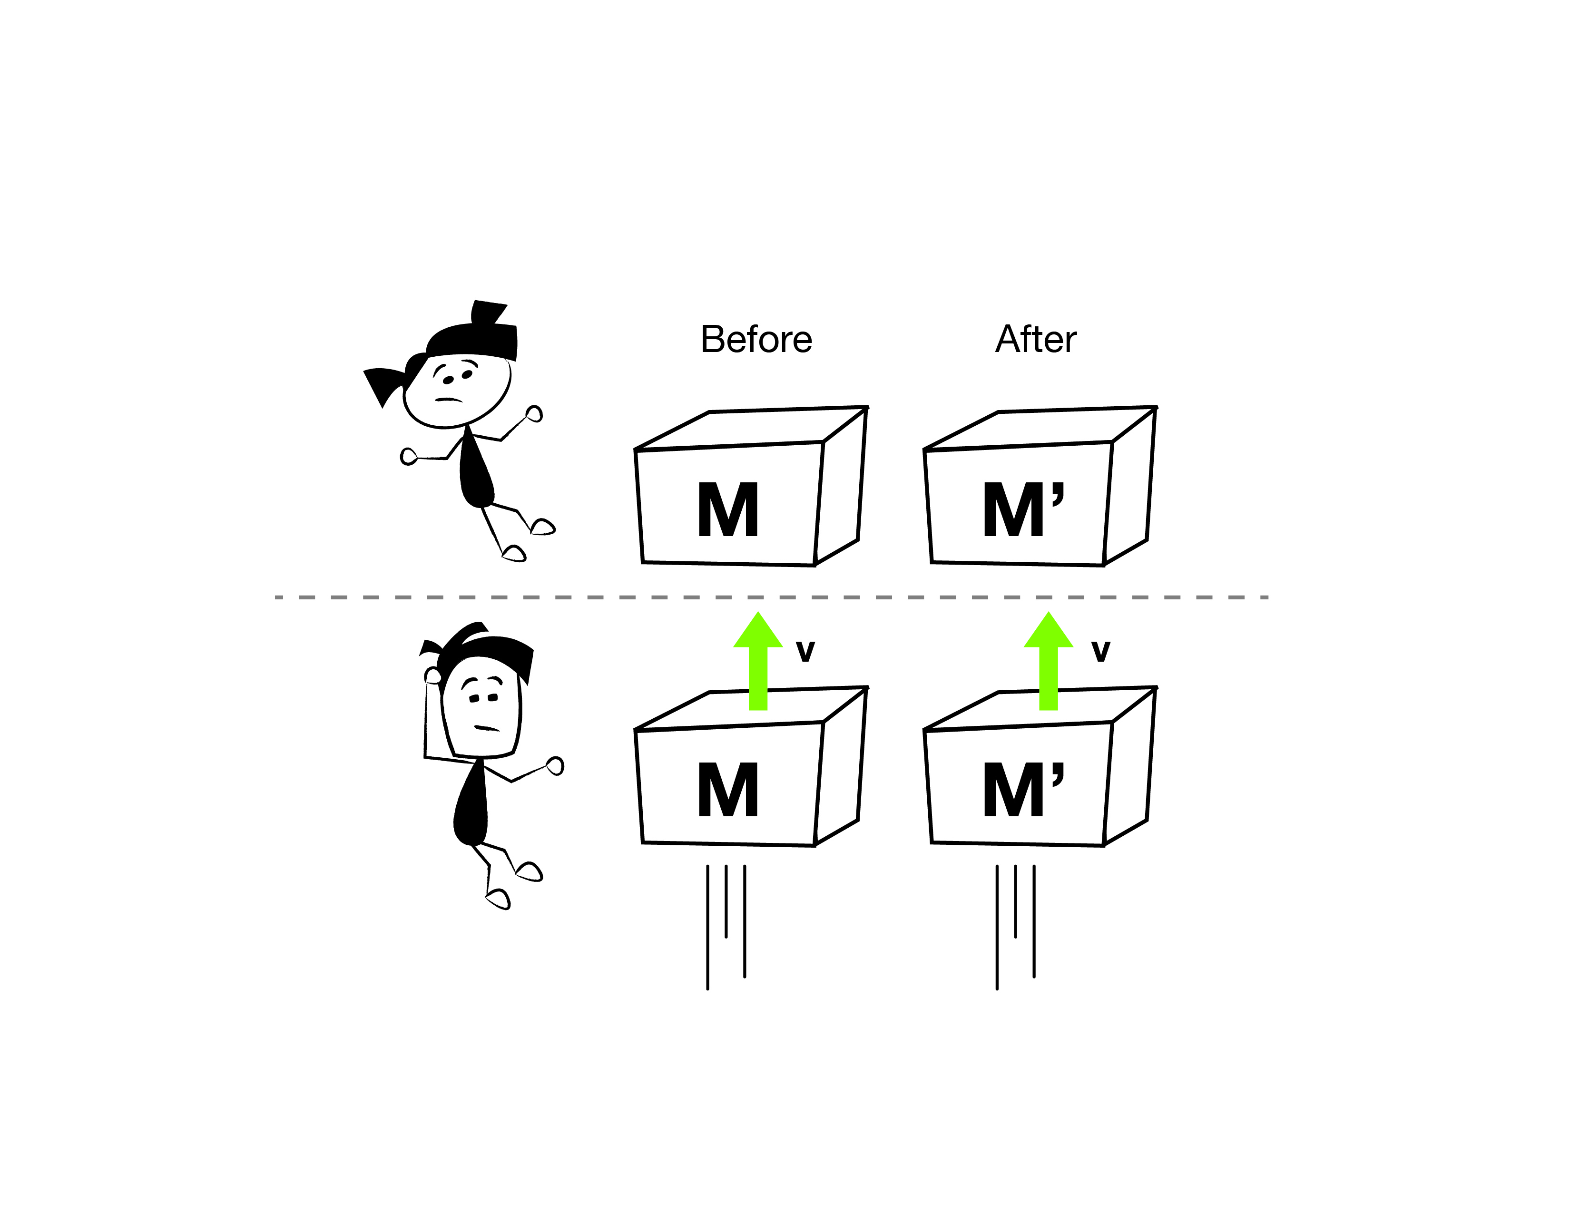

1. Alice comes across a box floating “at rest” in deep space. She has no idea what is inside. Nothing enters or leaves the box. Regardless of what might be happening inside, can the mass of the box change from $M$ to some different value, $M'$? Why or why not?



1. Bob is drifting by Alice and sees the same box moving at constant speed, $v$. How can Bob use conservation of energy and/or momentum to explain that any change in mass is impossible?
2. The “before” picture below left shows that the box contains two particles at rest, each of mass $m$; one is matter and the other is antimatter. In the “after” picture, below right, the matter and antimatter have annihilated each other, and have been transformed entirely into light (two photons flying off in opposite directions).
   1. Alice has put the “before” box on a weigh scale. Does its weight change? Explain.
   2. Bob uncovers a window on the box and lets out all the light. What is the change in mass of the box? (Express your answer quantitatively in terms of $m$.) How is this change in mass related to the amount of energy that left the box?

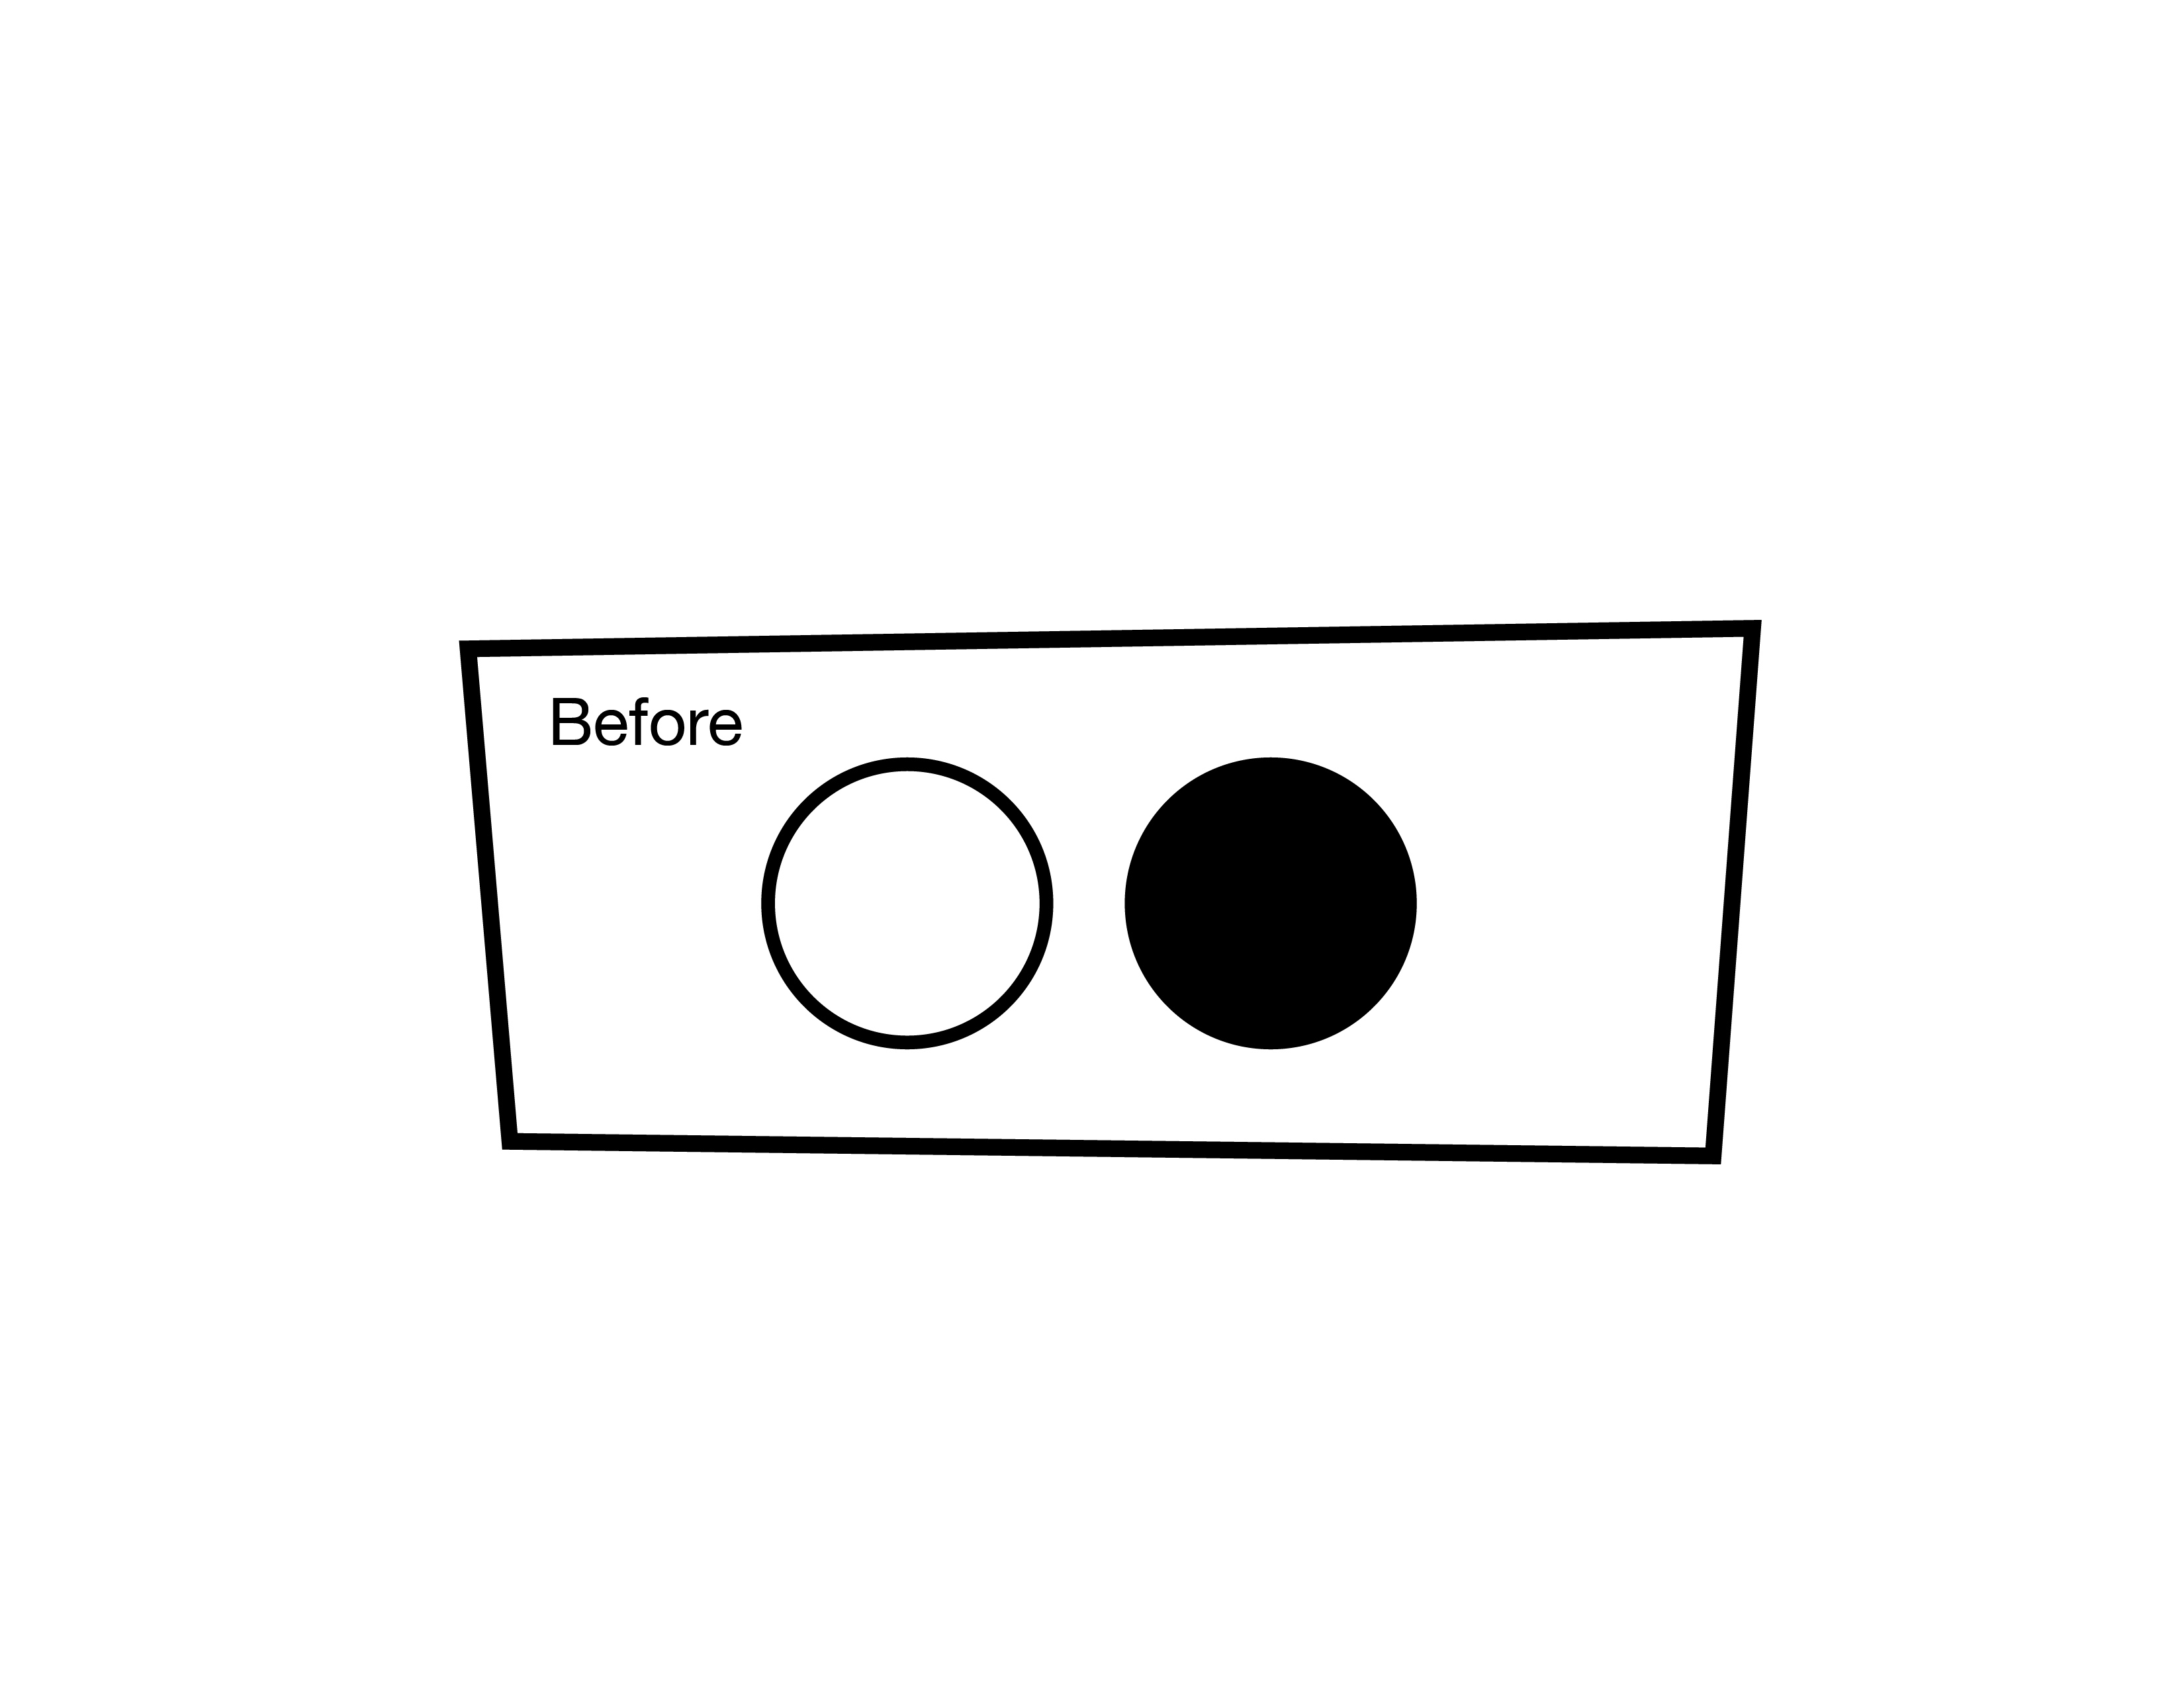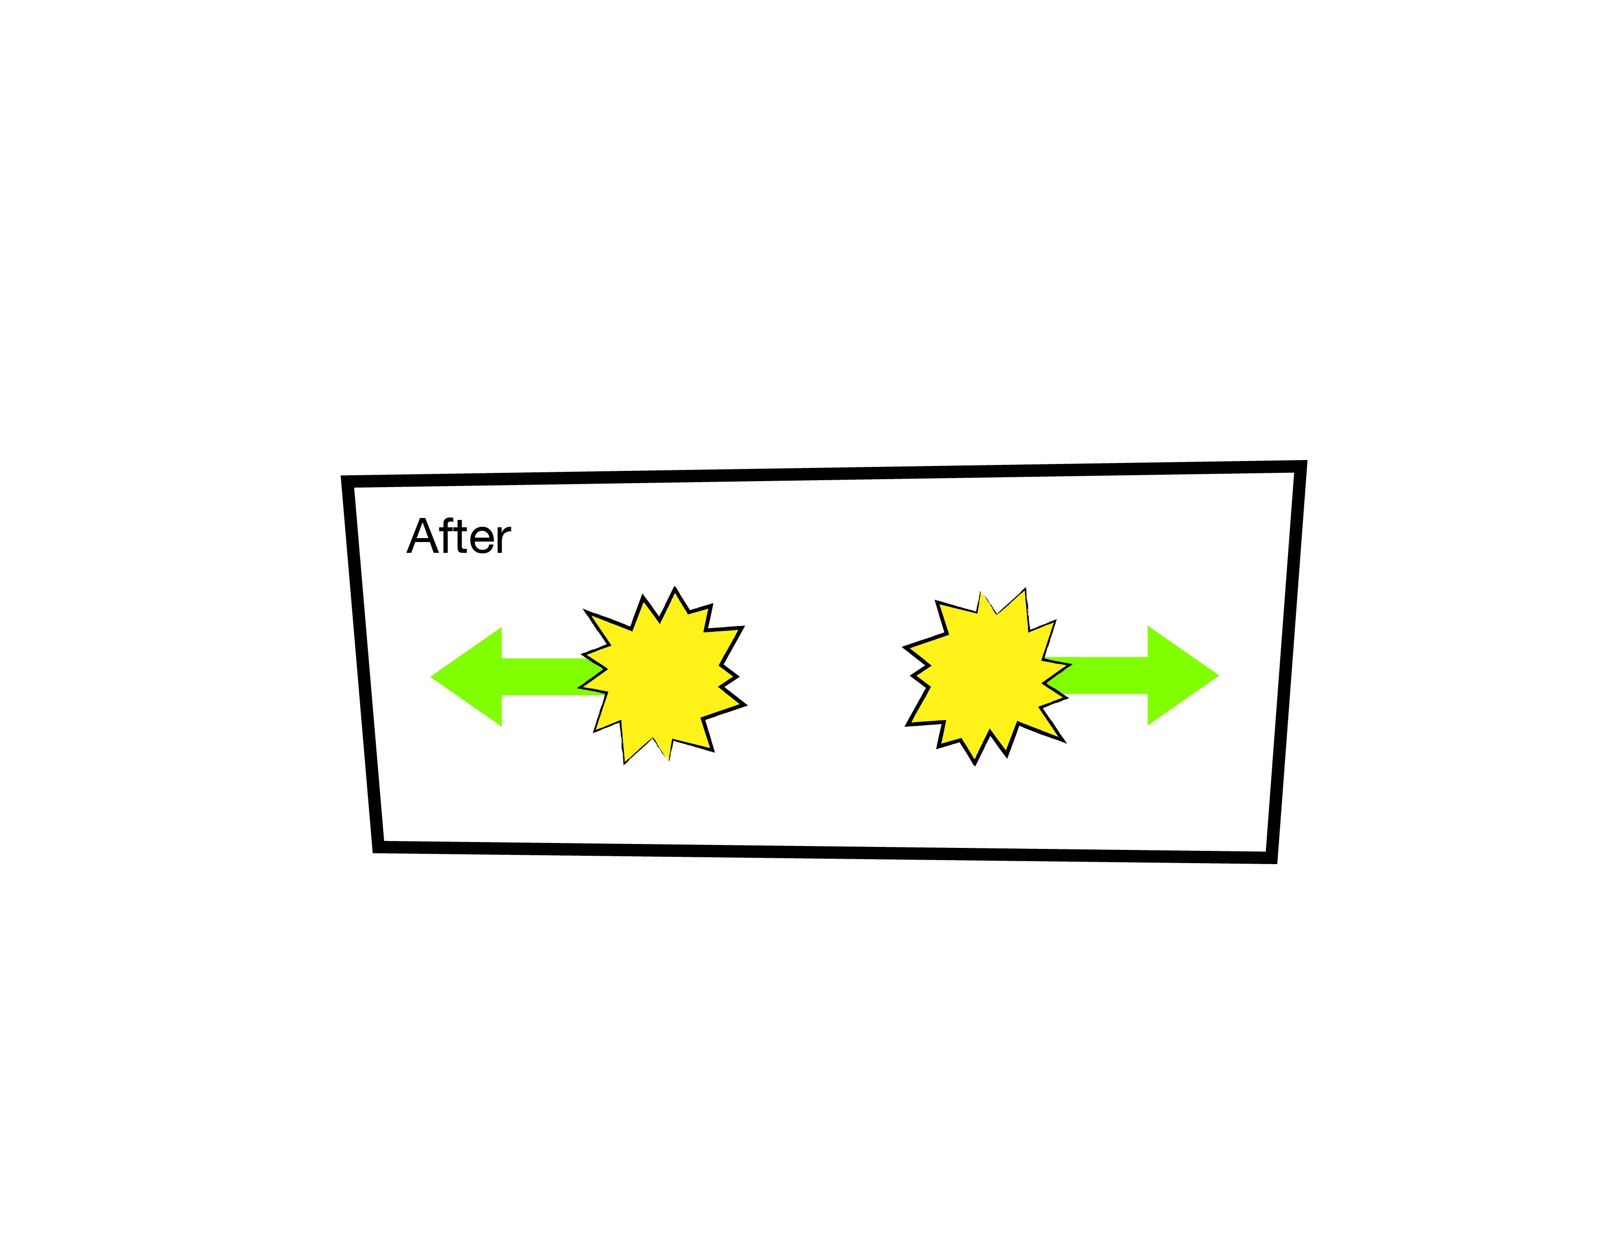

1. Summarize the argument leading to the statement: **According to Einstein’s special theory of relativity, adding light (or thermal radiation) to a box increases its mass. It weighs more, and is harder to accelerate. If the amount of light energy is $E$, the increase in mass is ${m=E/c}^{2}$.**

**Hawking Temperature Thought Experiment Part 3―Thermodynamics**

In this part of the thought experiment we will think about our winch-and-black-hole machine as a *heat engine*, and apply the laws of thermodynamics to figure out the (classical) temperature of a black hole.

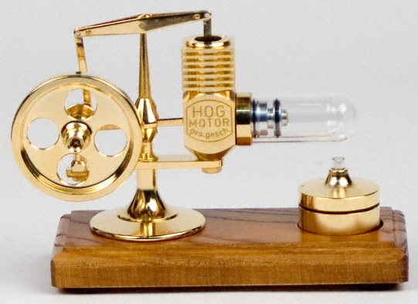A heat engine is a machine that converts thermal energy into mechanical work. For example, the *Stirling engine* in the demo operates roughly as follows (refer to the diagram):

1. The flame acts as the “hot reservoir at temperature $T_{H}$” in the diagram. During each cycle of the engine, an amount of thermal energy, $Q_{H}$, flows from the flame into the air that is trapped inside the cylinder. This air is called the *working fluid*. (No air enters or leaves the engine―it just expands and contracts.)
2. 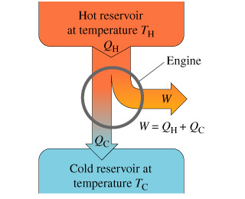This thermal energy, $Q_{H}$, heats the working fluid (at temperature $T_{H}$), causing it to push against the piston and expand, doing useful work. The working fluid then expands further as it cools to temperature $T_{C}$, doing more useful work.
3. In order for the piston to return to its starting position it must compress the working fluid. This takes away from the useful work you can get out of the machine. Since it’s easier to compress a cold gas than a hot one, we need some way to keep the gas cool as it compresses. (Normally, a gas heats up as it compresses.) To do so, the working fluid dumps an amount of thermal energy, $Q_{C}$, into the surrounding air via the cooling fins you see in the demo model. The surrounding air acts as the “cold reservoir at temperature $T_{C}$” in the diagram.
4. Finally, just like the air inside a bicycle pump gets hotter when you compress it, there is a final bit of compression that heats the working fluid from cold to hot, i.e., $T_{C}$ to $T_{H}$. The engine is now ready to start a new cycle. The *net* amount of useful work (expansion work minus compression work) you can get out of the machine on each cycle is $W$.

**Summary:** During each cycle, an amount of thermal energy, $Q_{H}$, enters the engine. Part of this energy goes into the useful mechanical work you get out, $W$, and the rest goes into *wasted* thermal energy, $Q_{C}$.

**Questions:**

1. Use conservation of energy to express $W$ in terms of $Q_{H}$ and $Q_{C}$.
2. The *efficiency* of a heat engine, $e$, is defined as the “useful energy you get out during each cycle” *divided by* the “total energy you put in during each cycle”. (Why is this a sensible definition? What does it mean for the engine to have $e=1$, i.e., to be 100% efficient?) Using your answer to Question #1, express the efficiency, $e$, in terms of $Q_{H}$ and $Q_{C}$.
3. The second law of thermodynamics says that “the entropy of an isolated system never decreases”. It always increases, or, at best, stays the same. “Entropy” is a measure of disorder, or randomness. It turns out that the flow of thermal energy, $Q_{H}$, *out* of the hot reservoir *reduces* the entropy of the hot reservoir by the amount ${Q_{H}}/{T_{H}}$. On the other hand, the flow of thermal energy, $Q_{C}$, *into* the cold reservoir *increases* the entropy of the cold reservoir by the amount ${Q_{C}}/{T_{C}}$. The most efficient heat engine would be one in which the net change in entropy is zero. In other words, the entropy lost by the hot reservoir is exactly equal to the entropy gained by the cold reservoir, so there is no net increase in entropy. This is expressed by the relation ${Q_{H}}/{T_{H}={Q_{C}}/{T_{C}}}$. Use this relation, together with your answer for Question #2, to express the efficiency as
$$e=1-\frac{T_{C}}{T_{H}}$$

4. This efficiency is the *theoretical maximum possible efficiency* of any heat engine. In practice, most heat engines (e.g., a steam engine, an internal combustion gasoline engine, an aircraft jet engine, etc.) are not this efficient. The Stirling engine in the demo actually operates very close to this theoretical maximum, at least in principle (that’s what makes it so cool!). Assuming that the temperature of the alcohol flame is about 900 degrees Celsius, estimate the efficiency of this Stirling engine. (Remember to convert all temperatures to the Kelvin scale! In physics, temperature is *always* measured in Kelvin. Kelvin = Celsius $+ 273$. The absolute zero of temperature is $0$ K, or about $-273$ degrees Celsius.)
5. We will now think about our winch-and-black-hole machine as a *heat engine*, and apply what we have learned about efficiency. We will take the temperature of the “hot reservoir” to be the temperature of the thermal radiation we trap in the box before winching it down. We will take the temperature of the “cold reservoir” to be the temperature of the black hole (this is where we are dumping any wasted thermal energy).[2] Recalling Question #2 above, and the discussion in the Introduction section, how does the “total energy you put in during each cycle” compare with the “useful energy you get out during each cycle”? What does this tell you about the *efficiency* of our black hole heat engine? Recalling Question #3 above, what does this tell you about the *temperature* of a black hole?
6. Summarize the argument leading to the statement: **According to thermodynamics, this implies that a black hole has a temperature $T_{BH}=0$ (absolute zero), i.e., it emits no thermal radiation and so is black.**

**Hawking Temperature Thought Experiment Part 4―Quantum Theory**

In this part of the thought experiment we will take into account the *height* of the box (labelled $d$ in the diagram on page 1), and recognize that it affects how much useful mechanical work we can extract at the winch. We will also apply quantum ideas to discover that the height, $d$, has a certain *minimum* value―it cannot be zero, and this limits the efficiency of our heat engine. By then rethinking our thermodynamic efficiency argument in Part 3, we will discover that a black hole is *not* black, i.e., it has a non-zero temperature.

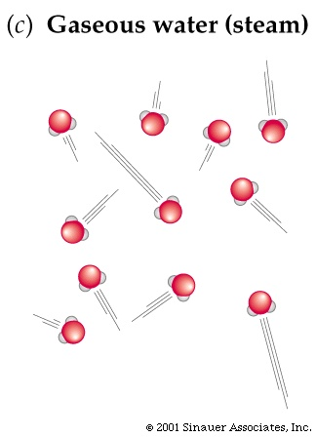

Let’s start by thinking about *temperature*. What *is* temperature? As you increase the temperature of a solid or a liquid, its atoms or molecules jiggle around more vigorously. They *store more energy*: both kinetic energy (energy of motion) and potential energy (energy in the stretched or compressed interatomic bonds). As you increase the temperature of a gas, the gas particles, on average, move at greater speeds, and hence store more kinetic energy. *Temperature* is directly a measure of the average *energy* stored in the random thermal agitation of atoms or molecules making up solids, liquids and gases. Up to a proportionality constant, temperature is *defined* as the amount of thermal energy per atom or molecule.

The simplest example is a monatomic gas like helium, neon, or argon. Being a gas, its atoms cannot store potential energy (why not?). Being a *monatomic* gas, the atoms can store kinetic energy only in their *motion*, and not in their *rotation* (compare with a *diatomic* gas, in which the molecules are like little dumbbells that can tumble end-over-end, storing appreciable amounts of rotational energy). In this case, the *temperature* of the gas and the *average thermal energy per atom* are related by the simple definition:

$$E_{atom}=\frac{3}{2}kT$$

Here $T$ is the temperature of the gas (in the absolute temperature scale, Kelvin), and $k$ is a universal constant of nature called the Boltzmann constant. The Boltzmann constant is the conversion factor between temperature and energy. Don’t worry too much about the numerical factor of $3/2$. (It comes from the fact that, in any system at temperature $T$, each microscopic “degree of freedom” stores an average amount of thermal energy $kT/2$. A monatomic gas atom has $3$ such microscopic degrees of freedom: it’s freedom to move in the $x$, $y$, or $z$ directions. Three times $kT/2$ equals $3kT/2$.)

**Questions:**

1. In our thought experiment, we have filled a box with the thermal radiation emitted by an object at temperature $T$. Let’s think of this thermal radiation as a “photon gas”: zillions of particles (photons) bouncing around inside the box, much like air molecules bouncing around inside a room. Up to a possible numerical factor (like the $3/2$ in the above formula), which we will ignore, estimate the average thermal energy per photon, $E_{photon}$, in a photon gas at temperature $T$.
2. Like any elementary particle, if a photon has energy, it also has momentum. According to Einstein’s special theory of relativity, an object with rest mass $m$ has energy $E=mc^{2}$ when it is at rest. If we set the object in motion, it will have some additional energy (*kinetic* energy) related to its momentum, $p$. Einstein’s *general* relationship between energy, mass and momentum is: $E^{2}=m^{2}c^{4}+c^{2}p^{2}$. When the object is at rest its momentum is zero, and the more general formula reduces to the familiar $E=mc^{2}$ (do you see how?). When the object has zero rest mass, like a photon, what is the relationship between energy and momentum? What is the average momentum of a thermal photon in a photon gas at temperature $T$?
3. According to quantum theory, a particle with momentum $p$ behaves like a wave with wavelength $λ=h/p$ (the de Broglie relation), where $h$ is Planck’s constant. What is the average wavelength of a thermal photon in a photon gas at temperature $T$?
4. 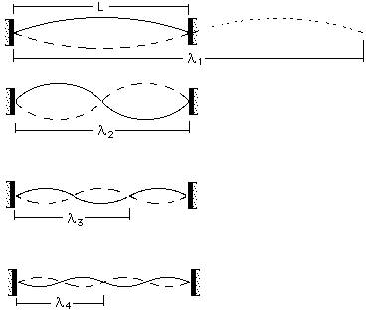When we confine a wave to a box, it reflects off the walls, and we get a superposition of waves travelling in opposite directions, forming *standing waves*. The diagram shows the allowed standing waves on a string (which can be thought of as a one-dimensional box). Given the wavelength calculated in Question #3, what is the *minimum* height of our box, $d$, that would allow the thermal photons to “fit” inside? (Note that since this answer involves Planck’s constant, it is a *quantum* effect.)
5. Consider the following facts:
   1. In Part 1, we considered lowering an object of mass $m$ from a great height down to the event horizon of a black hole using a winch. We discovered that, according to Einstein’s model of gravity, the amount of useful mechanical work we could extract at the winch was equal to the entire rest mass energy of the object: $E=mc^{2}$.
   2. In Part 2 we showed that the thermal radiation inside the box has mass; we can think of it as an “object of mass $m$” that we are lowering down. The fact that the box has a minimum height $d$ means we cannot lower it *all* the way down. The centre of mass of the thermal radiation can only be brought to within a distance $d/2$ of the event horizon (why?). Thus, the amount of energy we can extract is slightly *less* than $mc^{2}$.
   3. When the object is near the event horizon, the force we need to apply *at the winch* to keep it from falling is equal to the *mass of the object* ($m$) times what’s called the *surface gravity of the black hole*: $g=c^{4}/4GM$, where $M$ is the mass of the black hole. This force, times the distance we winch the object down, represents mechanical work we can extract at the winch.

Using these facts, determine the amount of mechanical work (useful energy) we can *actually* extract at the winch. Express your answer in the form: $mc^{2}(1-X)$, where you need to figure out $X$.

1. In Part 3 we thought of our black-hole-and-winch as a thermodynamic heat engine that converts thermal energy into mechanical work. The *efficiency* of this heat engine, $e$, is defined as the “useful energy you get out during each cycle” [which in our case is $mc^{2}(1-X)$] divided by the “total energy you put in during each cycle” [which in our case is $mc^{2}$]. In Part 3 we figured out that this efficiency could also be expressed by the formula:

$$e=1-\frac{T_{BH}}{T}$$

where $T$ is the temperature of the thermal radiation inside the box, and $T_{BH}$ is the temperature of the black hole. Compare your formula for efficiency with this formula to figure out $T_{BH}$. Compare your answer with the answer Steven Hawking got:

$$T_{BH}=\frac{hc^{3}}{16π^{2}kGM}$$

Because we ignored a numerical proportionality constant above, we shouldn’t expect to get exactly the same answer, but we should be *close*. Are we?

1. Summarize the argument leading to the statement: **According to thermodynamics, the quantum effect considered in Part 4 reduces the efficiency of our heat engine, and implies that the black hole has the non-zero temperature, $T_{BH}$, given above.**

1. Hawking radiation does not come from *inside* a black hole―remember that nothing, not even light can escape a black hole! Instead, it comes from a region outside of, but very near to the event horizon.
2. The “temperature of a black hole” is *not* the “temperature of space” at the event horizon (whatever that could mean!). It is the temperature of the thermal radiation (Hawking radiation) coming from the black hole, as measured by a person sitting a very great distance from the black hole.